**Department of Electrical Engineering**

|  |  |
| --- | --- |
| **Faculty Member: Sir kaleem-ullah** | **Dated: 1/5/19** |
|  |  |
| **Course/Section: BEE-8D** | **Semester: 6** |
|  |  |

**EE-330 Digital Signal Processing**

**Lab#11 FIR filter design using Windowing**

|  |  |  |  |  |  |  |
| --- | --- | --- | --- | --- | --- | --- |
|  |  | **PLO4-CLO4** | | **PLO5-CLO5** | **PLO8-CLO6** | **PLO9-CLO7** |
| **Name** | **Reg. No** | **Viva / Quiz / Lab Performance** | **Analysis of data in Lab Report** | **Modern Tool Usage** | **Ethics and Safety** | **Individual and Team Work** |
|  |  | **5 Marks** | **5 Marks** | **5 Marks** | **5 Marks** | **5 Marks** |
| **Muhammad Anus Siddiqui** | **174308** |  |  |  |  |  |
| **Muhammad Haris Rehman** | **182797** |  |  |  |  |  |
| **Muhammad Hasnain Afridi** | **192414** |  |  |  |  |  |

**Lab12: FIR filter design using Windowing**

**Objectives**

* The principal objective of this lab is to demonstrate FIR Filter design using windowing.

**Lab Instructions**

* This lab activity comprises of three parts: Pre-lab, Lab Exercises, and Post-Lab Viva session.
* The lab report shall be uploaded on LMS three days before next scheduled lab. The Pre-lab tasks should be completed before coming to the lab and hard copy of Pre-lab session should be deposited with teacher/lab engineer at start of the lab for necessary evaluation. Alternatively, the reports can be submitted in PDF format on LMS.
* The students should perform and demonstrate each lab task separately for step-wise evaluation (please ensure that course instructor/lab engineer has signed each step after ascertaining its functional verification)
* Only those tasks that completed during the allocated lab time will be credited to the students. Students are however encouraged to practice on their own in spare time for enhancing their skills.

**Lab Report Instructions**

All questions should be answered precisely to get maximum credit. Lab report must ensure following items:

* Lab objectives
* MATLAB/C codes
* Results (graphs/tables) duly commented and discussed
* Conclusion

# FIR Filter Design with MATLAB

## 

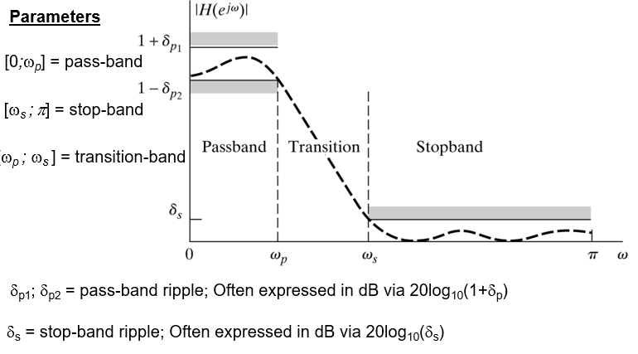

## Lab task 1

Design a lowpass FIR filter with a passband cutoff frequency of 1 kHz, a stopband edge at 4.3 kHz, and a sampling frequency of 10 kHz.The transition width is the difference of the stopband edge and the passband edge. Thus, the normalized transition width is Δf.

* Plot the ideal impulse response
* Plot actual impulse response
* Plot frequency response

**Code:**

N = 50; % FIR filter order

Fp = 1000; % 20 kHz passband-edge frequency

Fst = 4300; % 20 kHz passband-edge frequency

Fs = 10000; % 96 kHz sampling frequency

Rp = 0.00057565; % Corresponds to 0.01 dB peak-to-peak ripple

Rst = 1e-4; % Corresponds to 80 dB stopband attenuation

eqnum = firceqrip(N,Fp/(Fs/2),[Rp Rst],'passedge'); % eqnum = vec of coeffs

h = impz(eqnum);

figure(1)

plot(h)

figure(2)

stem(h)

%H=tf(1,eqnum);

fvtool(eqnum,'Fs',Fs,'Color','White') % Visualize filter

%freqz(eqnum,1);

%figure(1);%

%impulse(tf(H));

**Output:**

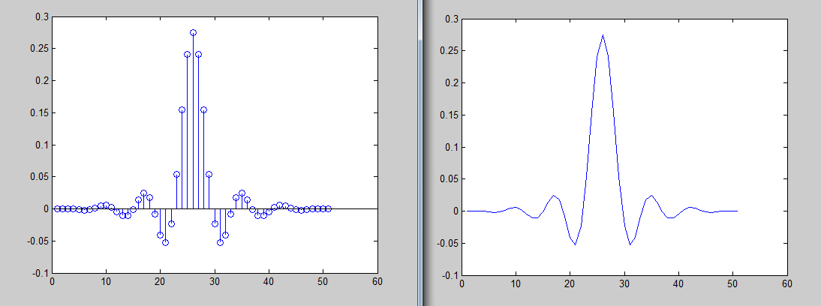

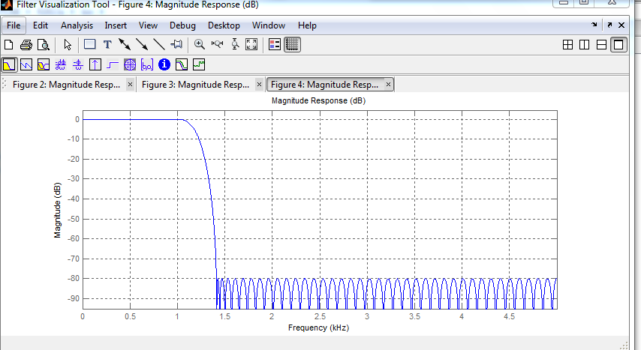

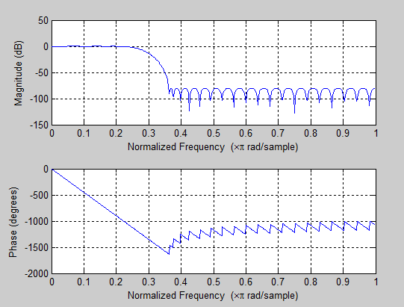

**Second approach by Using fir1:**

*b = fir1(N-1, Wn, filter_type, window);*

*b≡ filter numerator coefficients*

*Wn≡ normalized cutoff frequency (or frequencies) of the filter*

*filter_type≡lowpass, highpass, bandpass, bandstop*

*window≡ the window coefficients, e.g. Hamming, Blackman, etc.*

We must now determine the normalized cutoff frequency for MATLAB. Remember this is to be normalized to **Fs/2.** Here our cutoff frequency is 1 kHz so

**Here are some examples of using the fir1 command:**

*b = fir1(N-1, 0.5); ‘lowpass filter using Hamming window*

*b = fir1(N-1, 0.5, blackman(N)); ‘lowpass filter using Blackman window*

*b = fir1(N-1, 0.5, ‘high’, boxcar(N)); ‘highpass filter using rectangular window*

*b = fir1(N-1, [0.2 0.5]); ‘bandpass filter using Hamming window*

*b = fir1(N-1, [0.2 0.5], ‘stop’, hanning(N)); ‘bandstop filter using Hanning window*

***code:***

Fc=1000;%1k

Fs=10000;%10k

N=50;%length or order of filter

wc=2*Fc/Fs;

b=fir1(N-1,wc, hamming(N));%coefficients

freqz(b,1)

%fvtool(b,'Fs',Fs,'Color','White') % Visualize filter

h = impz(b);

figure(1)

plot(h)

figure(2)

stem(h)

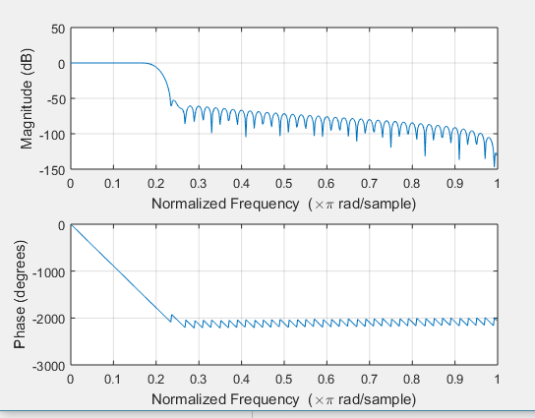

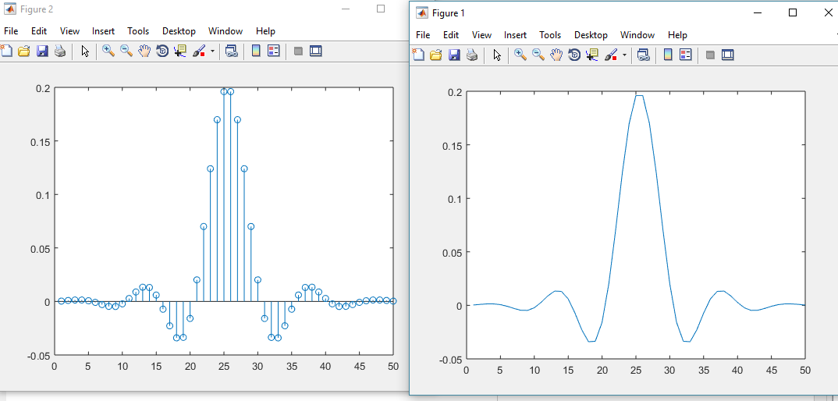

### Lab Task 2:

Design Bandpass Filter in Matab .

*Fs = 48 kHz*

*Passband Cutoff Frequencies = 8 kHz & 16 kHz*

*Stopband Edge Frequencies = 7 kHz & 17 kHz*

*Hamming Window*

* Plot the impulse response
* Plot Magnitude response
* Plot Phase response

**Code:**

Fc=[8000 16000];

Fs=48000;%48k

N=50;%length or order of filter

wc=2*Fc/Fs;

b=fir1(N-1,wc, hamming(N));%coefficients

freqz(b,1)

fvtool(b,'Fs',Fs,'Color','White') % Visualize filter

h = impz(b);

figure(1)

plot(h)

figure(2)

stem(h)

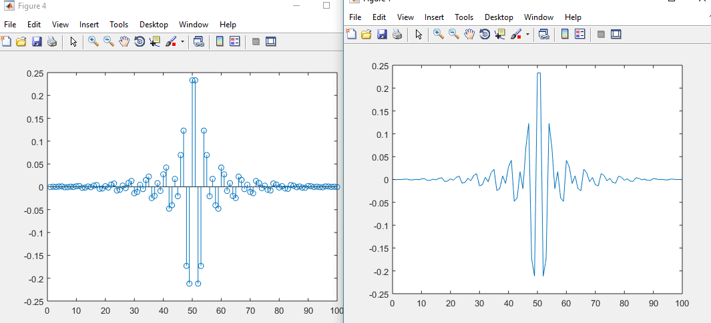

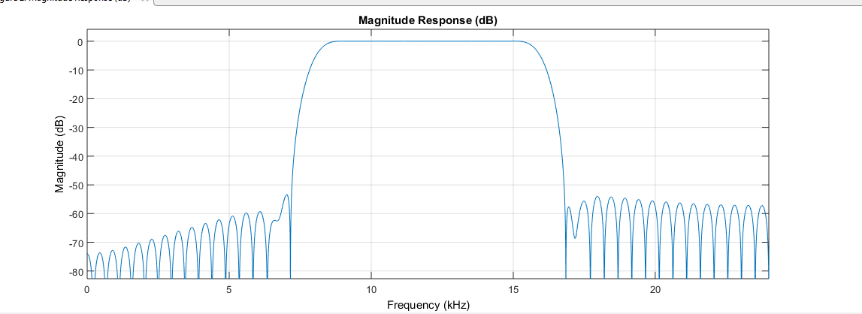

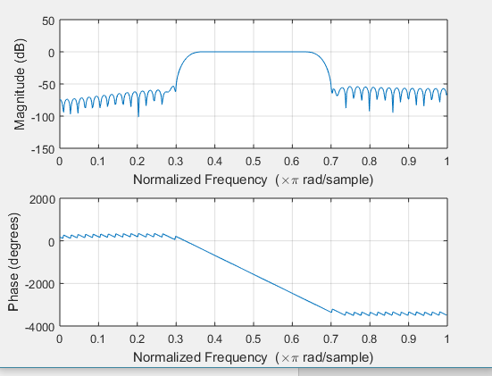

### Lab Task 3:

1. Design IIR and FIR Filter digital bandpass filter with following specification .



These quantities are shown in the following figure.



* 1. Plot the impulse response
  2. Plot Magnitude response
  3. Plot Phase response

**Using IIR FILTER in fdatool:**

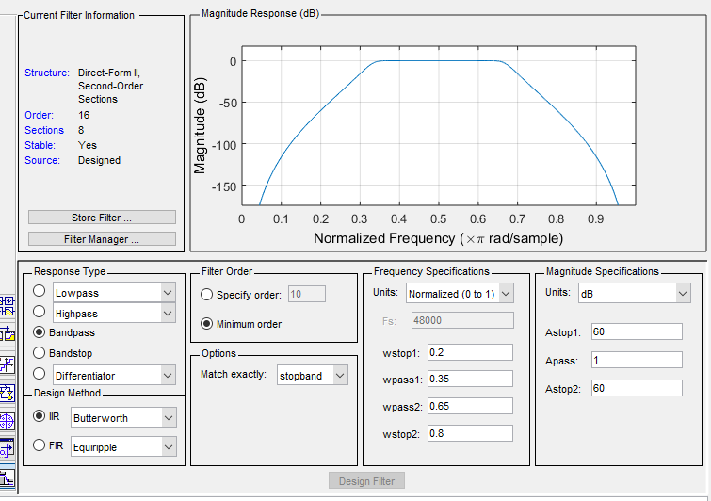

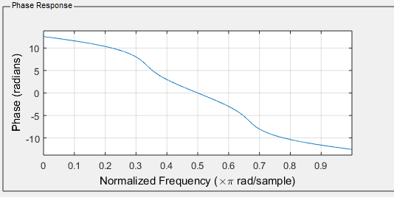

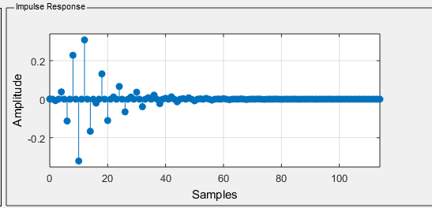

**Using FIR FILTER in fdatool:**

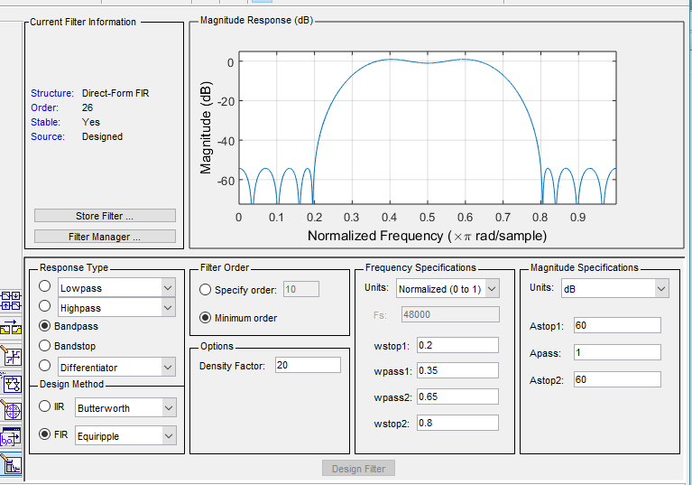

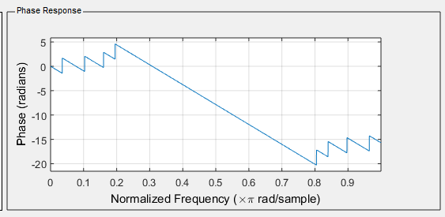

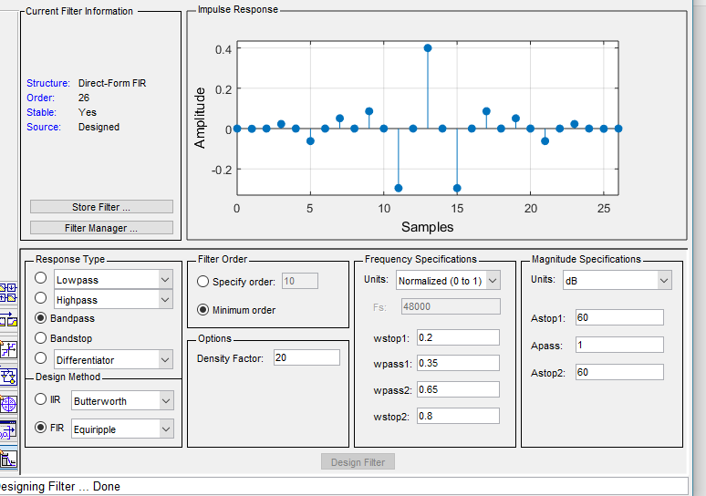

1. Compare both the filter and explain how would you choose which filter(FIR or IIR) is more appropriate for a particular application.

The main difference is the smooth transition from pass band to stop band and this is due to the stable designing of the IIR filters as they contain both the poles and zeros in their transfer functions. While the FIR filters only contain the zeros which can’t independently describe the whole filter design and leave some ripples in both pass and stop bands. Moreover, the limited number of samples can be seen in the impulse response (stem response). This makes the computational efficiency better in FIR as compared to IIR.

**Conclusion:**

The basic gain from this lab is the FIR filters designing which includes all kinds of filters like low-pass, high-pass, band-pass, band-stop. The advantages and disadvantages of both FIR and IIR designing was done.